PROJECT REPORT - IBM BUILD-A-THONTelecom Customer Churn Prediction using Watson Auto AI

**NISHIT KHAITAN**

Email: nishitk@gmail.com

Institution mail: 1ms18cs086@msrit.edu

The software specification for the proposed system is as follows:

**IBM Watson Studio:**Watson ML Package - 'Lite'  
Instance Type - 'v2'  
Environment Definition - Default Python 3.6XS  
Virtual Hardware Configuration - 2 vCPU 8GB RAM  
COS Instance Region - 'London'

**Python Flask Application:**HTML5  
Flask

**Python Libraries required:**scikit-learn  
pandas  
numpy  
seaborn  
json  
sklearn.preprocessing  
sklearn.model_selection  
sklearn.feature_selection

* Projects Page-

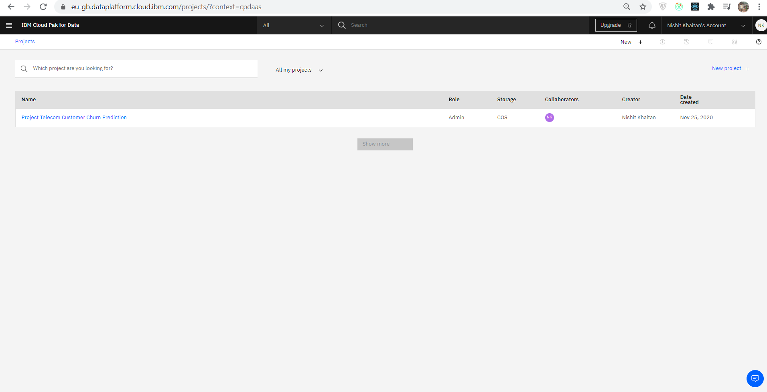

* Creation of Project and addition of assets-

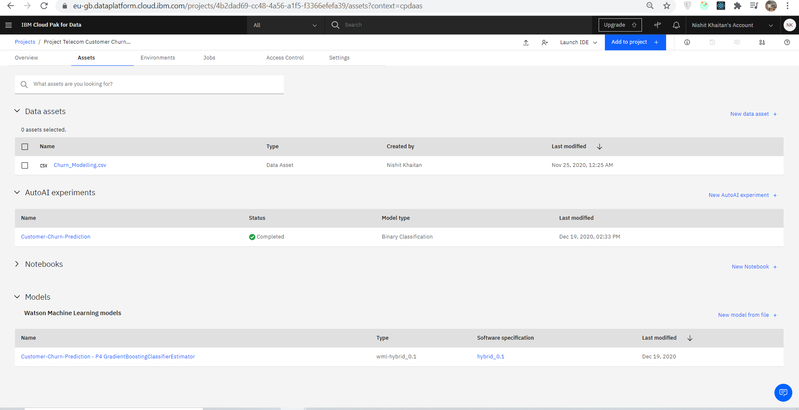

* The dataset –

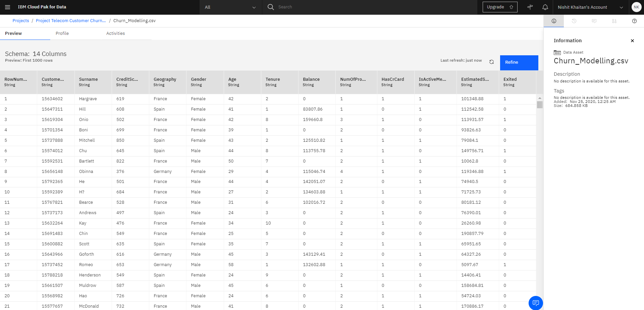

* The experiment summary-

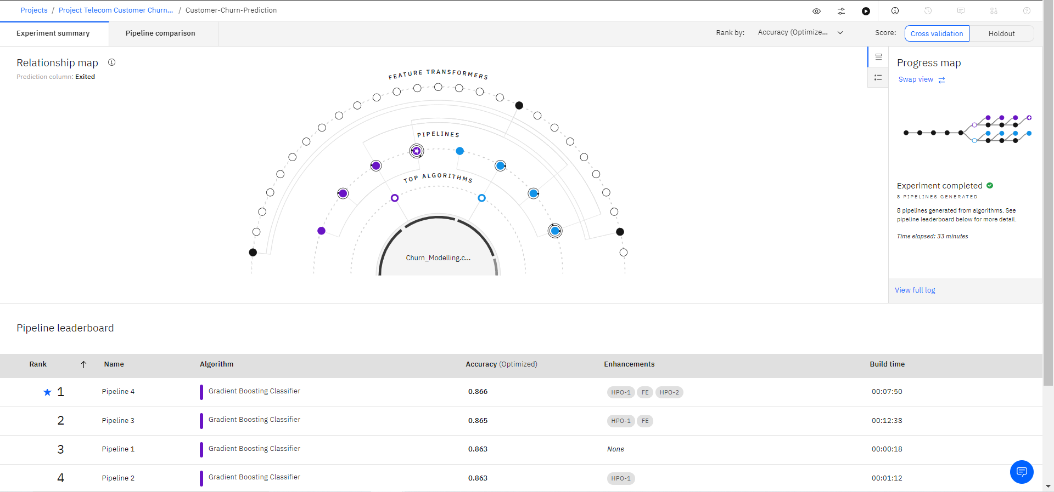

* Pipeline Comparison

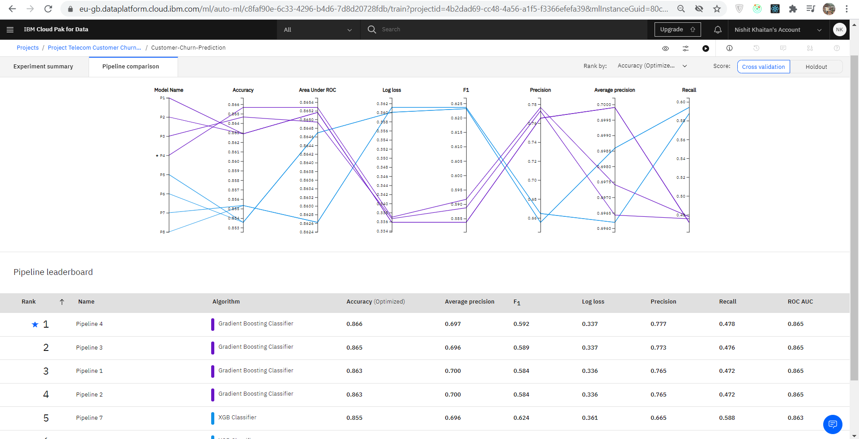

* Deployment Stage-

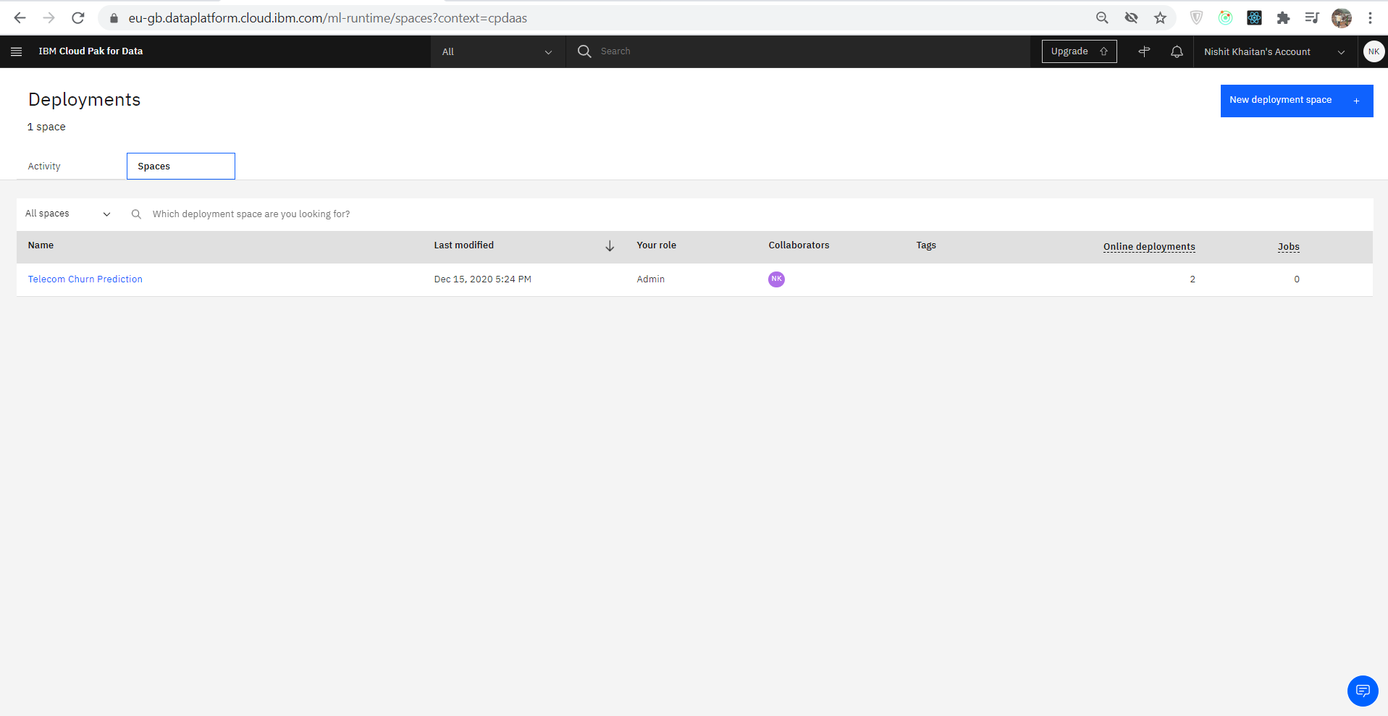

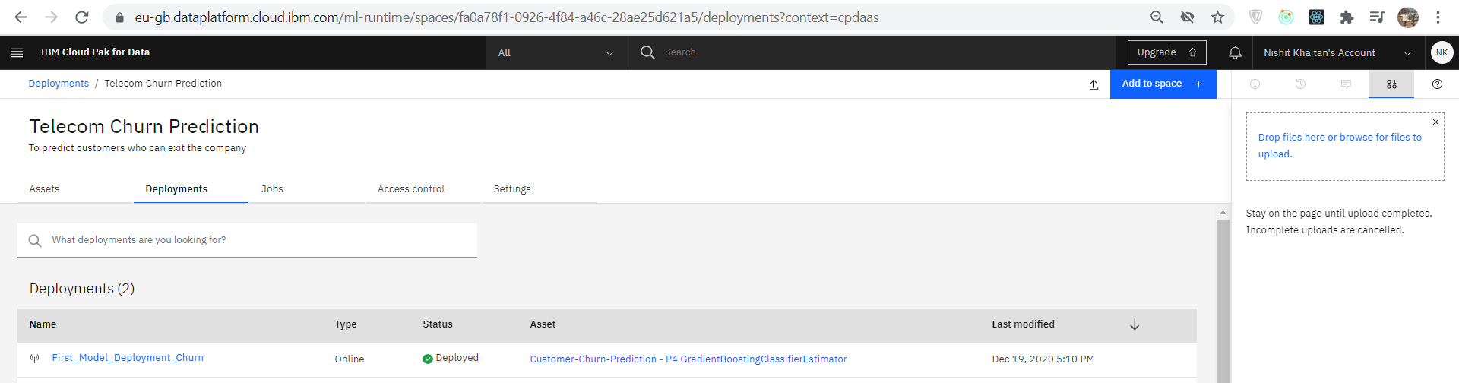

* Testing the model:

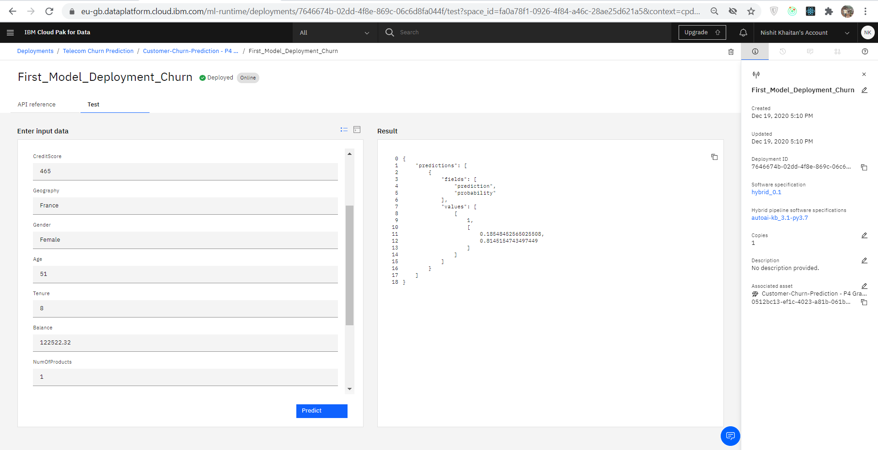

* API Snippet:

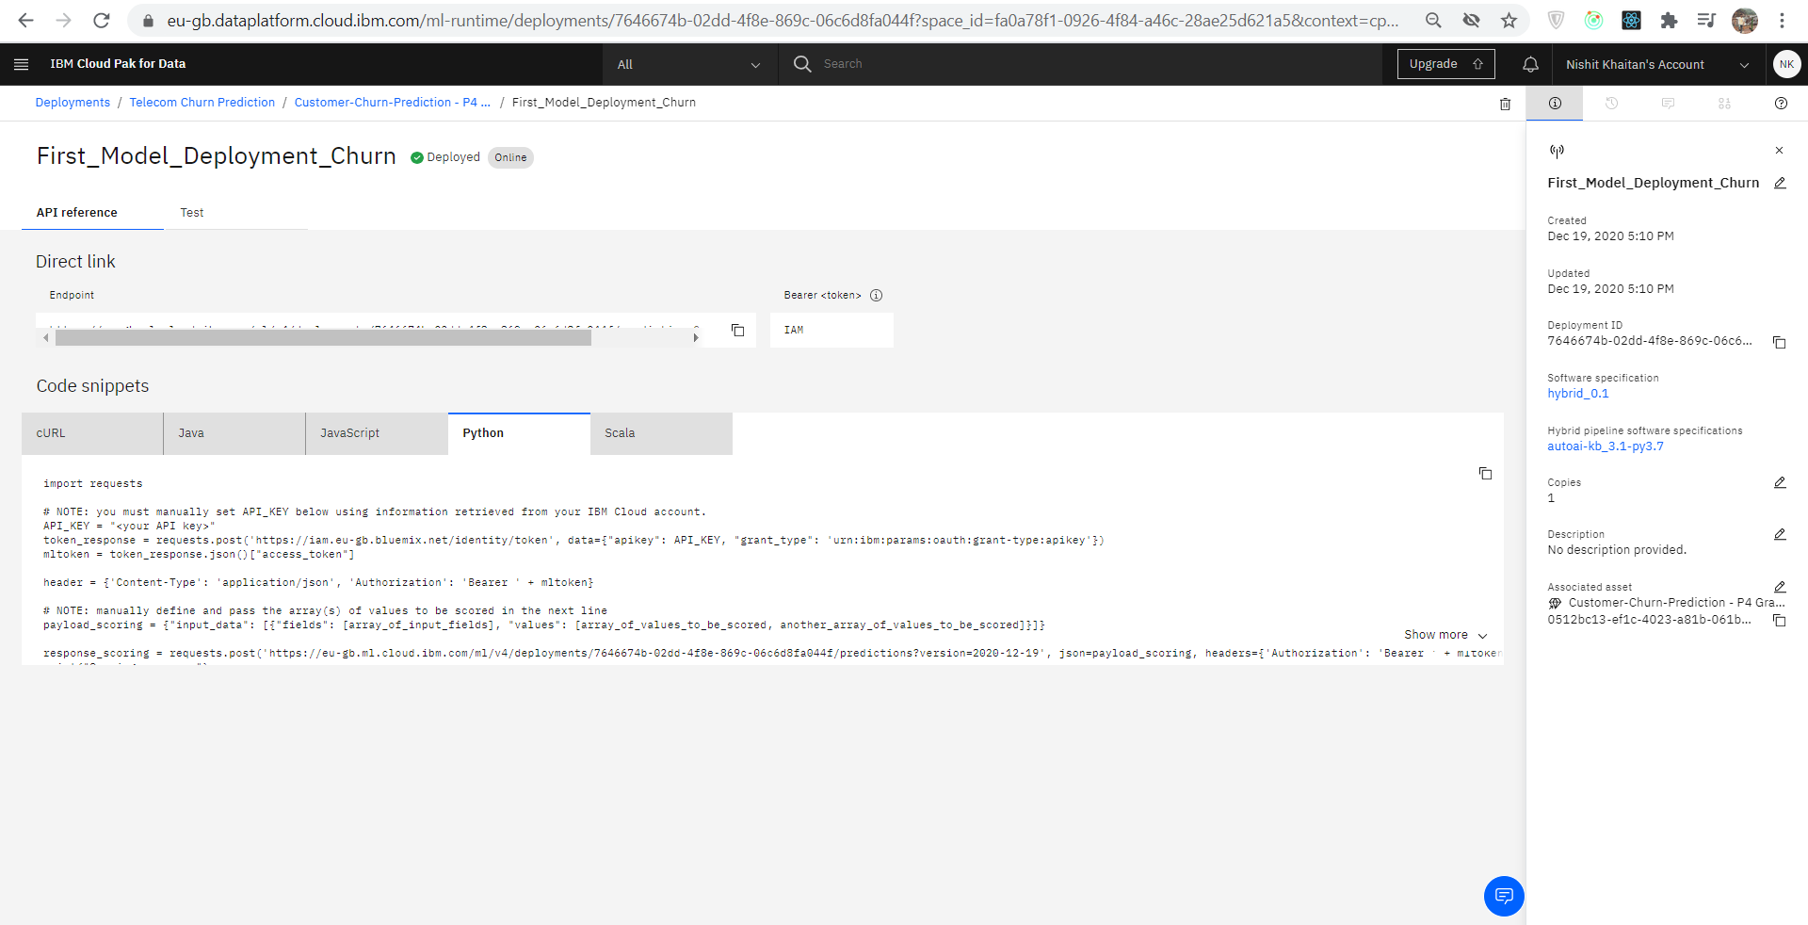

Web Application:

